№3
Напишите скрипт для суммы OrderQty для каждого года и зимних месяцев из Production.WorkOrder в виде транспонированной матрицы:
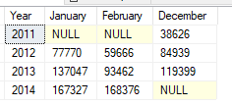

SELECT [YEAR], [1] AS January, [2] AS February, [12] AS December
FROM
(SELECT YEAR (EndDate) AS [YEAR], OrderQty, MONTH (EndDate) AS MONTH1
FROM Production.WorkOrder
WHERE MONTH (EndDate) IN (1, 2, 12)
) AS SourceTable
PIVOT
(
SUM(OrderQty)
FOR MONTH1 IN ([1], [2], [12])
) AS PivotTable
ORDER BY [YEAR]

